Business Rates Appeal Consultation

Purpose of report

For information.

Summary

This report outlines the LGA’s response to the current Department for Communities and Local Government (DCLG) consultation on Business Rates Appeals which closed on 3 March 2014. The response was cleared by the LGA Executive on 20 February.

Recommendation

That the Panel note the final response to the Department for Communities and Local Government’s (DCLG) consultation which was submitted to DCLG on 3 March 2014, following consideration by the Executive and Finance Panel Officer Holders.

Action

Officers to continue to discuss next steps with DCLG and the Valuation Office Agency.

Contact officer: Mike Heiser
Position: Senior Adviser (Finance)
Phone no: 020 7664 3265
E-mail: mike.heiser@local.gov.uk

Business Rates Appeal Consultation

Background

- It was announced in the Autumn Statement that the Government would bring forward proposals to streamline the business rates appeal system. The consultation document “Checking and Challenging your rateable value” was issued in December 2013. It closed on 3 March 2014.

Business Rates Appeals

- Business rates appeals have become a key issue for local authorities since the introduction of business rates retention in 2013. Previously local authorities were simply the collection agency for government. The risk to local authority budgets is greater because of the Government’s decision that the risk from all unresolved appeals before 2013 should be shared 50 per cent by local government and 50 per cent by central government, as opposed to allowing appeals from before April 2013 to be set off against the old national business rates pool.

The size of the risk

- In total 1.4 million challenges to both the 2005 and 2010 lists have been made. 11.7 per cent (168,000) are still unresolved. The Government has committed to clearing 95 per cent of the appeals currently outstanding by July 2015. The Valuation Office Agency (VOA), which is responsible for rating valuation and appeals, does not currently provide statistics on the total amount of tax income that is covered by these ongoing appeals. Therefore local authorities have to estimate this for themselves.

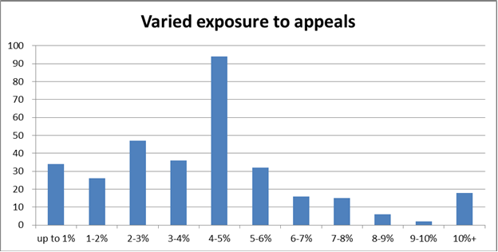
- There is significant variation between authorities in the size of the backlog, with billing authorities facing backlogs of 4.5 to 24.6 per cent of total appeals raised in relation to 2005 and 2010 rating lists. The authorities with the greatest number of appeals tend also to be those collecting the highest levels of business rates income. Similar information about the total rateable value being challenged can be got from the chart below which shows the provision for appeals which councils made in their NNDR1 form for 2013-14. Councils have dealt with this in different ways. It can be seen that it was most common for councils to make provision for appeals which represented 4-5 per cent of their total taxbase. However, almost 20 councils had appeals which represented over 10 per cent of their total taxbase by value. Worryingly, there are still almost 13,000 unresolved challenges in relation to the 2005 rating list.

- Overall, the scale of the appeals backlog means that councils operate in an environment of financial uncertainty. While historic data shows that about a quarter of appeals go in the favour of businesses, councils across England have to make less favourable assumptions in their budget planning process so as to avoid any unexpected impact on their ability to deliver services.

- This means that the size of the backlog affects the funding that councils can confidently allocate to the provision of public services and potentially exacerbates the impact of government grant reductions.

- Our research in November 2013 showed that some councils forecasted potential losses on challenges to be as high as 45 per cent of their total business rate income, although typically around 75 per cent of appeals go in favour of the authority and against the appellant.

- The VOA has been working to reduce the backlog but is hampered by a system which it is widely agreed is in need of reform.

The Government proposals

- The aim of the proposals are, according to the Government:

  - improve the transparency of the valuation process (including disclosure of more information on rental evidence). This will allow ratepayers to check their rateable value without having to make a formal challenge, improve confidence in rateable values and overall confidence in the rating system;

  - bring business rates into line with the way official decisions are normally challenged by requiring ratepayers to provide with their challenge an explanation of why they think the rateable value is wrong; and

  - enshrine in law a more formal separation in the challenge process between the Valuation Office Agency and the Valuation Tribunal for England by more clearly separating the administrative “proposal” stage in the Valuation Office Agency from the independent judicial “appeal” stage in the Valuation Tribunal for
England.
- The document says that savings should arise to businesses as it would reduce the number of speculative challenges and it would provide greater financial certainty to local government.

The LGA draft response

- The LGA response, which is attached at Appendix A, says the following:

  - The measures proposed should, if accompanied by clear targets on clearing the backlog of appeals, enable the system of appeals to become more transparent and streamlined which is good for the public purse as a whole. At the same time they do not appear to place a new burden on businesses.

  - The best way of reducing the risk from appeals would be to allow appeals from before April 2013 to be set against the old national business rates pool. This is a point we have made in our reply to the Local Government Finance Settlement.

- The report was considered by the LGA Executive on 20 February 2014. It was agreed, with the addition to a reference to the effect on decisions of whether or not to pool for business rates retention purposes. This was incorporated into the final version of the response.

Conclusion and next steps

- The consultation document says that, if the response to the consultation is positive, the Government intends to implement the new system from 1 October 2014. Officers will continue to discuss implementation with officials from DCLG and the VOA.

- Business rates in general have received a considerable amount of attention in recent weeks from think tanks and bodies representing the business community. The general theme of this commentary is that business rates has become too expensive for the business community or for selected types of businesses. Among those commenting have been the Federation of Small Businesses, the CBI, the British Retail Consortium, the Institute for Fiscal Studies and, more recently, the BIS Select Committee. There is no consensus among these commentators about the alternative that should be adopted. The next phase of work for the LGA will need to involve formulating our response to these comments.

Financial Implications

- This is core work for the LGA and will be contained within existing budgets.

